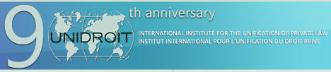

CREATING A FAVOURABLE LEGAL ENVIRONMENT FOR CONTRACT FARMING
– THE UNIDROIT/FAO/IFAD LEGAL GUIDE ON CONTRACT FARMING

UNIDROIT in collaboration with FAO and IFAD, under the auspices of the Ministry of Foreign Affairs and International Cooperation in Italy

Unidroit, Via Panisperna 28, 00184 Rome

Rome, 27 April 2016 – 8.30 a.m. – 12.30 a.m.

Registration Form

to be completed for each participant and returned as soon as possible to the Unidroit Secretariat at f.ghin@unidroit.org – confirmation of registration will be given in due course

Your details:

Mr – Ms

Surname ……………………………..……………………………….…………………………………………………….

Name ………………..…………………………………………………………………………….………………...…

Position ………………………………………………………………………………………….……………………….

Institution ………………………………………………………………………………………………………………….…

…………………………………………………………………………………………………………………….

Address …………………………………………………………………………………………………………...……….

…………………………………………………………………………………………………………………….

Country …………………………………………………………………………………………………………………….

e-mail ……………………………………………………………………………………………………………………

language (for documentation) English French

